✴

**Template**

**Develop shared understanding and empathy**

Summarize the data you have gathered related to the people that are impacted by your work. It will help you generate ideas, prioritize features, or discuss decisions.

Empathy map canvas

Use this framework to empathize with a customer, user, or any person who is affected by a team’s work.

Document and discuss your observations and note your assumptions to gain more empathy for the people you serve.

Originally created by Dave Gray at

Does it recorded already?

Information on offers and discounts

***What do they see?***

***Marketplace Environment Others***

Message customers

Solving queries

Call service

Notifying illegal access and calls

***What do they THINK and FEEL?***

[**Share template feedback**](https://muralco.typeform.com/to/CiqaHVat?typeform-source=app.mural.co)

# What do they HEAR?

***From friends?***

# From colleagues? From second-hand?

How to you advertise people?

Does it reaches every people?

***PAIN***

What other thoughts and feelings might influence their behavior?

***Fears, agitation and frustrations***

Difficult for rural people`

***GAIN***

***Wants, necessities and confidence***

Customers from multiple language

Chat in scripted form

***What do they say?***

***What we heard from them say?***

Polite and fast response

Booking of servive

Immediate rectification of problem

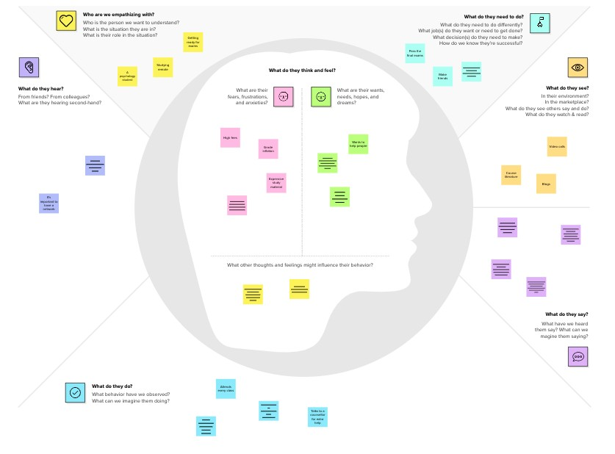

**Need some inspiration?**

See a finished version of this template to kickstart your work.

[**Open example**](https://app.mural.co/template/018339d6-ff71-42d8-9e5c-abddde77d5ab/982236e0-c7e5-4fb6-83e9-ef1b972b25bd)